WORK REPORT
Form No.: FM-HW-005
Project Name | : | {{project_name}} |  | Date | : | {{doc_date}}
Project ID | : | {{project_code}} |  | Customer | : | {{customer}}
Start | : | {{start}} |  | Site Address | : | {{site_address}}
Completed | : | {{completed}}

PROJECT DESCRIPTION
{{description}}

COMPLETED DELIVERABLES
- {{deliverable}}

LESSON LEARNED
- {{lesson}}
PROJECT SCHEDULE REPORT
Task | Planned |  | Actual
Task | Start | Finish | Start | Finish
{{sched.task}} | {{sched.plan_start}} | {{sched.plan_finish}} | {{sched.actual_start}} | {{sched.actual_finish}}
PROJECT SCHEDULE NOTE
{{note.task}} | {{note.text}}
PROJECT TEAM / RESOURCE LIST
Role | Multipolar |  | Customer
Project Manager | {{pm_mlpt}} |  | {{pm_customer}}
{{team.label}} | {{team.mlpt}} |  | {{team.customer}}
{{team.label}} | {{team.mlpt}} |  | {{team.customer}}

OPERATION TRAINING / KNOWLEDGE TRANSFER TO CUSTOMER
Date |  |  | {{training_date}}
{{att.label}} |  |  | {{att.name}}
 |  |  | {{att.name}}
DOCUMENTATION
Document type |  |  |  | Received date |  |  | Received by
{{docs.type}} |  |  |  | {{docs.date}} |  |  | {{docs.by}}
CUSTOMER SURVEY
No | Question |  |  |  |  |  | 1 | 2 | 3 | 4 |  | 5
1 | Technical design and project implementation meet customer‘s plan and expectation.
2 | The Implementation teams were adequately skilled in terms of technical knowledge.
3 | Project issues were resolved effectively by the right people and in a timely manner.
4 | The documentation (Design and implementation) created is fit for purpose.
5 | Comment :
1= Strongly Disagree |  | 2= Disagree |  | 3= Neutral | 4=Agree | 5= Strongly Agree
Note: Please provide feedback comments if the survey is given less than or equal to 3.

PREPARED BY |  | ACKNOWLEDGED BY |  | CUSTOMER’S SIGNATURE
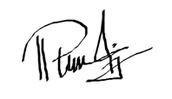
Name | : {{prepared_name}} | Name | : {{acknowledged_name}} | Name | : {{customer_name}}
Title | : {{prepared_title}} | Title | : {{acknowledged_title}} | Title | : {{customer_title}}
Date | : {{prepared_date}} | Date | : {{acknowledged_date}} | Date | : {{customer_date}}

Support Mechanism
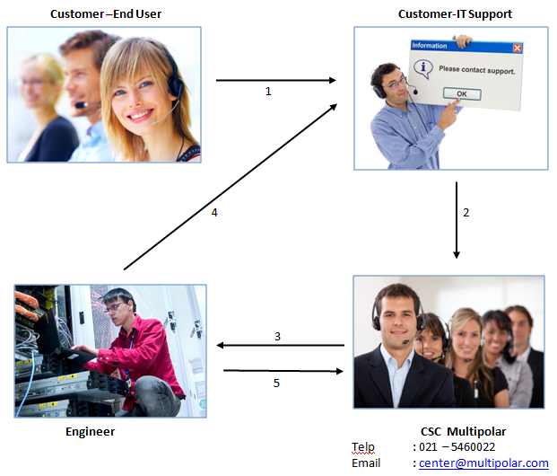
Multipolar is offering the CUSTOMER to contact Multipolar’s Customer Service Center (MPC CSC) for any problem/disturbance that occurs within the maintenance period. Furthermore, below will further explain how the 1st level of support works.
Figure 1 First Level Support Mechanism
Problem Reporting/Logging Mechanism
- Customer contact its IT Support,
CUSTOMER should contact its help desk shall there be any disturbance/problem in the operation of the CUSTOMER’s system .
IT Support identify problem
Should it be under Multipolar’s responsibility, the CUSTOMER’s help desk should then contact Multipolar’s Customer Service Center.
- Customer IT Support Contact Multipolar Customer Service Center (CSC)
PT. Multipolar Technology – Customer Service Center
Telephone : (021) 557 777 070
E-mail : center@multipolar.com
Furthermore, CUSTOMER should provide the following information: Office address, Contact person, Problem priority, Problem description.
- Multipolar CSC escalate to engineer and logs report
Multipolar’s Customer Service Center escalate problem to engineer and logs the problem in the database.
- Multipolar engineer Contact Customer
Multipolar’s Engineer will contact the CUSTOMER within one hour and assist CUSTOMER to solve the problem.
- Multipolar Engineer contact Customer Service Center (CSC)
Multipolar’s Engineer will then report to the CSC that the problem has been solved or other status of the problem.
Support Service Type and Period | Acknowledged by customer |  | Support Service Signature
- {{svc_hw}} Hardware Warranty / {{svc_silver}} Silver Maintenance / {{svc_gold}} Gold Maintenance / Periode : {{support_period}}
 | Name | {{customer_name}} | Name | {{support_signer}}
 | Date | {{doc_date}} | Date | {{doc_date}}

